Application for CRAFT Vendor Space
Event Dates: Sept2-4, 2022
Application Deadline: Ju ly 3 1, 2022

Business Name: Name of Contact Person: Mailing Address:

City:
State:
Zip:

Telephone: Email:
Product description: List ALL products to be displayed and/or sold at festival. Acceptance of your application is based on your product list. Please include a photo of your booth or display if this is the first time vending at this festival.We will limit the number of merchants at festival who sell similar products. You will not be allowed to sell products that are not listed on this application at the event -- so please be thorough, using a separate page if necessary. Vendors will be notified of acceptance no later than Aug 15, 2022. Payment will be processed immediately if accepted; applications submitted without payment in full will not be considered.

Note: Booth space is assigned by festival staff and requests for specific placement are not guaranteed.View of the stage is not guar-anteed. You MUST provide your own covered structure and tables. Sorry, electricity is not available to craft vendors. Per Reservoir Hill vehicle requirements, motorhomes must be 24’ or under; camper trailers must be 16’ or less in length, hitch excluded. Pets are not allowed on festival grounds. All vendors must purchase an annual 2022 Town of Pagosa Springs business license no later than July 31 (see instructions at the end of application). If you are applying to vend at both festivals you only need one license for the year.

Standard Booth.......................................................10’x10’ space (includes one vehicle parking pass & one worker pass) $375
Double Booth .........................................................10’x20’ space (includes one vehicle parking pass & one 3-day festival ticket) $550
Number of additional worker passes (limit 3 add’l. passes per vendor) x $90 $
Number of additional vehicle vendor passes (limit: 1 add’l. per vendor) x $50 $
TOTAL DUE $
PAYMENT II N FULL IS REQUIRED AT TIME of APPLICATION. A 50% FEE WILL BE CHARGED FOR CANCELLATIONS. No REFUNDS WILL BE MADE FOR CANCELLATIONS AFTER JULY 30, 2021.
Agreement: Sign and return this form with your payment. Please make check payable to KSUT. No application will be considered without payment in full. Payment will only be processed if application is accepted. I hereby make application for merchandise vending space at the 2022 Four Corners Folk Festival as described within. I have read and agree to abide by the terms on both pages of this application.

Signed Name
Check /M.o. / Amex/ ViSA / Mastercard (Circle one)
#

Title
Exp. Date
CVC Code

Date *Remember to attach complete product list.
Retain a copy for your records. return one signed copy with payment to: KSUT, P.O. Box 737, Ignacio, CO 81137, or email to festivaldirector@ksut.org. If you have any questions call Jill at (970)563.5788.

Date Received:
Festival Use Only
Size of Booth:

Amount Paid:

Liability
Terms and Conditions of Contract for Crafts exhibitors
The sales tax rate is 6.9% -- 2.9% to the State of Colorado and

Exhibitor agrees to indemnify and hold harmless KSUT and
the Four Corners Folk Festival (hereafter referred to as FCFF), its principals, agents, officers and employees from all claims, losses, costs, damages or expenses resulting or arising from any and all injuries to or death of any person or damage to any property caused by an act, omission or neglect of Exhibitor’s agents, employees, invitees, contractors, or guests which occur in or about the Exhibit Space. Exhibitor agrees to use and preoccupy the Exhibit Space at Exhibitor’s own risk, and hereby releases FCFF, its agents, officers, employees and invitees from all claims for any damage, loss or injury to persons or property to the full extent permitted by law occurring in or about the Exhibit Space, including, but not limited to damages, resulting from the acts of other Exhibitors, theft, vandalism, fire and other casualty damage or damage arising from any defects in the premises.

Space Assignments
KSUT will assign booths in all cases; specific requests for
placement will not be honored.

Festival Passes, vehicle passes and camping
All people age 13 and over on festival grounds (this includes vending area) must have a festival pass. Please purchase the number of passes required when you complete the application; worker passes will not be available at the gate. The first and sec- ond vehicle passes are valid for leaving and re-entering festival grounds. Any additional vehicle passes will be for camping pur- poses only and do not allow for re-entry to festival once vehicle is driven off the property. The following vehicles are allowed on the festival site: motorhomes 24’ or shorter; pop-up camper trailers; non pop-up camper trailers 16’ or less in length; cabover campers; passenger cars, trucks, vans and SUVs; motorcycles. Longer trailers and motorhomes or fifth wheels are not allowed on Reservoir Hill. Vendors must camp in the designated Vendor Camping or purchase a regular festival & camping pass. Pets are not allowed anywhere on Reservoir Hill.

Installation of Exhibits
Exhibitors MUST arrive at the site on Wednesday, Aug 31st between 3 and 8 p.m. or Thursday, Sept 1st from 9 AM to 5 PM. THERE ARE NO PROVISIONS FOR THOSE WHO CAN- NOT ARRIVE BETWEEN THOSE HOURS.

Dismantling of Exhibitor Space
Exhibitor shall not dismantle or remove any portion of exhibit prior to end of show on Sunday, Sept. 4, 2022. The entire ex- hibit and all of Exhibitor’s property must be removed from the premises by 12:00 noon, Monday, Sept. 5, 2022. Failure to vacate the premises by this time will result in a citation for trespass- ing issued by the Town of Pagosa Springs and/or loss of future vending rights at KSUT festivals. Area shall be returned to KSUT in its original condition, and Exhibitor agrees to re- imburse KSUT for any cost or expense incurred by KSUT in cleaning up or repairing damage to site.

Exhibit Space
Electrical hookups are not available. Exhibits may not exceed dimensions on contract. Exhibitor may construct a semiper- manent booth that will not damage the site. Exhibitor may not exhibit any material deemed offensive or objectionable, in the reasonable opinion of the KSUT, to the adjacent or surround- ing Exhibitors, or to the festival as a whole. Generator use is not allowed on Reservoir Hill during the festival; solar power is encouraged.

Exhibit hours
Exhibitor shall maintain a responsible individual(s) in the Exhibit Space at all times during show hours. All Exhibit personnel must have a pass for admittance to festival site. Booths may be open for business any time after setup on Thursday. Exhibitor has option to sell during extended hours at own discretion. Exhibitor shall be responsible for the conduct of any employees, agents, visitors or guests in or about the Exhibit Space. Exhibitor shall cause all such employees, agents, visitors or guests to be familiar with all rules governing Exhibitors.

Taxes
Sales tax forms and envelopes will be distributed at time of setup
and collected by a KSUT staff member on Sunday evening.
4% to Archuleta County. Failure to collect and/or pay sales tax will be reported to the CO Dept. of Revenue.

Compliance with Law
Exhibitor, agents, employees, or assigns shall comply with all rules, regulations and requirements of the Fire Marshal of Pagosa Springs/Archuleta County, Colorado or any governmental entity having jurisdiction over the premises. Exhibitor may be required at KSUT’s sole option to immediately cease its operations without refund and vacate the Exhibit Space if Exhibitor’s operation thereof, or the conduct of its agents, employees, or assigns should be found to be in violation of any such lawful requirements.

Use of Exhibit Space
  - No sound system, noise makers, loudspeakers, microphones or other sound amplification or broadcasting devices of any kind may be used.
  - No demonstrations, trophies, decorations, portals, fountains, signs, banners, advertising matter or exhibits of any kind or character will be allowed in the aisles or public passageways or attached to the tent walls or posts outside the vending space.
  - General distribution of brochures, pamphlets, leaflets, flyers, newspapers, magazines or other literature or promotional materials of any kind or character is prohibited unless au- thorized by KSUT.
  - Exhibitor agrees not to use the Exhibit Space for any political or religious purpose. Solicitation of funds for any political, educational or charitable corporation or association or any other corporation, association, group, individual or cause of any kind or character is strictly prohibited.
  - Exhibitor agrees not to place any item or merchandise out- side of the designated Exhibit Space.
  - KSUT, at its discretion, reserves the right to assign Ex- hibitors to the best space available, and to make shifts in location as deemed necessary.
  - In all cases, Exhibitors wishing to insure their goods must do so at their own expense. KSUT is not liable for any claims for theft, damage, or injury in conjunction with the Exhibit Space.

Removal of Exhibits by KSUT
KSUT reserves the right to prohibit any exhibit (i) which, in KSUT’s reasonable judgment may detract from the general character of the festival; (ii) if the business or exhibition carried on by the Exhibitor or the manner of conducting the same is not as represented at the time of making the Contract or is not in keeping with the traditions or character of the festival; (iii) if the Exhibitor was entered under false pretenses; (iv) if the exhibit is in violation of any of the rules governing Exhibitors;
(v) Exhibitor displays or offers for sale any drug-related items or paraphernalia, legal or otherwise. If an exhibit is prohibited under the terms of this paragraph or because of a violation of any of the terms hereof, KSUT shall have the right, but not obligation, to remove the exhibit or any banner, advertising matter or other property of the Exhibitor situated within or about the Exhibit Space, but such removal shall in any event be at the cost and expense of Exhibitor, and Exhibitor shall im- mediately reimburse KSUT for any cost or expense incurred in removing Exhibitor’s exhibit or portion thereof. Under such circumstances, Exhibitor shall not be entitled to a refund of monies paid to KSUT under the terms of the Contract.

Safety Rules
  - Exhibitors shall take all necessary precautions for the safety of their personnel, other Exhibitors and all other persons upon the premises and shall comply with all applicable pro- visions of federal, state and municipal safety laws, building codes and ordinances to prevent accidents or injury.
  - All decorations of papers, corrugated paper, crepe paper, drapes and all cloth must be flame proof to meet the stan- dards of the local fire department. Festival management shall rule upon any questions, disputes or problems which may arise pertaining to matters specifically covered and agreed upon in the foregoing paragraphs of the contract and such rulings shall be binding upon all interested parties.

I have read and agree to these terms and conditions

How to apply for a business license on CitizenServe (Citizen Online Portal)

** Please Note: If you have already registered online, you can simply login. Under the tab “Services”, click
“Business Licenses”. Then on the left side click “Renew Your License”. **

Step One: Go to the Town’s website at: http://www.pagosasprings.co.gov/

Step Two: In the right hand corner of the Town’s website hover over the “Business” tab, then click on the first option on the list “Business Licensing”

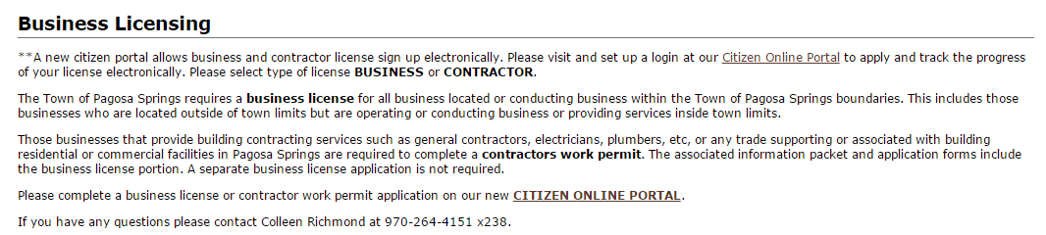Step Three: Then click on “Citizen Online Portal”

Step Four: In the top right hand corner click on “Login”

Turn Over

Step Five: Under the heading New to our Portal? on the right side, register now
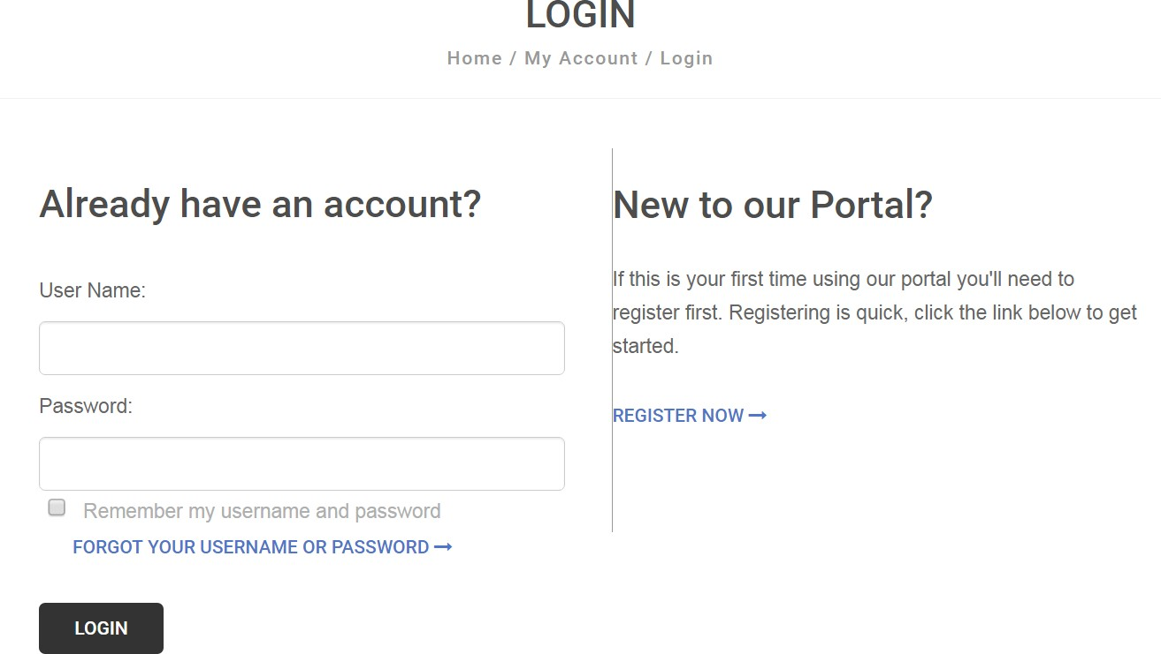

Step Six: Once registered, on the home page, under licensing, click “Apply for a License” and fill out the form with your business/contractor information and hit submit.

Please Note: A contractor must select Contractor Work Permit as a business license type as there are different requirements for a contractor.

How to renew a business license on CitizenServe (Citizen Online Portal)

Step One: Go to the Town’s website at: http://www.pagosasprings.co.gov/

Step Two: In the right hand corner of the Town’s website hover over the “Business” tab, then click on the first option on the list “Business Licensing”

Step Three: Then click on “Citizen Online Portal”

Step Four: In the top right hand corner click on “Login”

Turn Over

Step Five: Under the heading Already have an account? On the left side, sign in – if you need your username and password again, click FORGOT YOUR USERNAME OR PASSWORD.

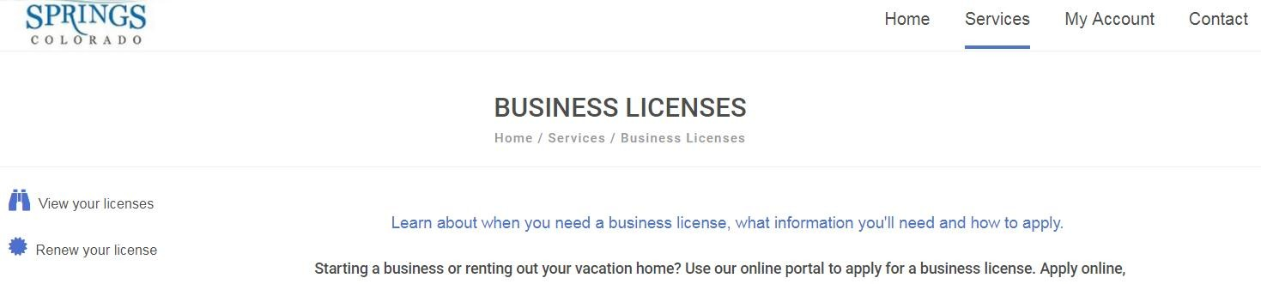Step Six: In the right hand corner select under “Services” “Business License” and on the right hand side click the icon Renew your license.

Then click on your license and click on the icon “Make a payment”

Then your all done! You will receive your business license as soon as it is approved by all departments. For questions you can contact Colleen Richmond, Deputy Town Clerk at 970-264-4151 x238.

